# Final Semester Project Progress

**KeyGuardian: A cybersecurity tool using C++ & Python**

# Report on

**Submitted in partial fulfillment for award of**

# BACHELOR OF TECHNOLOGY

**Degree**

**In**

# COMPUTER SCIENCE & ENGINEERING



## 2023-24

**Under the Guidance of: Submitted By:**

Surya Pratap Singh Chauhan (200330100232)

Surya Pratap Singh Chauhan (200330100232)

Mr. Mandeep Singh

Assistant Professor

### DEPARTMENT OF COMPUTER SCIENCE & ENGINEERING RAJ KUMAR GOEL INSTITUTE OF TECHNOLOGY

**5th K.M. STONE DELHI-MEERUT ROAD, GHAZIABAD**



**Affiliated to Dr. A.P.J. Abdul Kalam Technical University,**

**Lucknow**

**Raj Kumar Goel Institute of Technology Ghaziabad**

***ISO 9001:2015 Certified***

***5th KM. STONE, DELHI-MEERUT ROAD, GHAZIABAD (U.P)-201003***

## Department of Computer Science & Engineering

**Project Progress Report**

1. Course : Bachelor of Technology
2. Semester : 8th
3. Branch : Computer Science & Engineering
4. Project Title : KeyGuardian: A cybersecurity tool using C++ & Python
5. Details of Students:

|  |  |  |  |  |
| --- | --- | --- | --- | --- |
| S. No. | Roll No. | Name | Role as | Signature |
| 1 | 2000330100232 | Surya Pratap Singh Chauhan | Team Leader,  Coder, Documentation Head. |  |

1. SUPERVISOR:

Mr. Mandeep Singh

**Remarks from Project Supervisor:**

………………………………………………………………………………

………………………………………………………………………………

………………………………………………………………………………

# TABLE OF CONTENTS

**CHAPTER NO. TITLE PAGE NO.**

**ABSTRACT iii**

**LIST OF FIGURES vii**

**PLAGARISM REPORT viii**

**1. INTRODUCTION** 1

* 1. PROBLEM STATEMENT 2
  2. OBJECTIVE 3
  3. EXISTING SOFTWARE 4

1.4 BACKGROUND AND RELATED WORK 4

**2. HARDWARE AND SOFTWARE REQUIREMENTS** 9

**3. SDLC METHODOLOGIES** 10

**4. SOFTWARE REQUIREMENT SPECIFICATION AND ANALYSIS** 15

4.1 FUNCTIONAL REQUIREMENTS 15

4.2 NON-FUNCTIONAL REQUIREMENTS 16 4.3 DESIGN CONSTRAINTS 18

4.4 CONCLUSION 18

**5. RISK ASSESSMENT** 19

5.1 PROJECT RISKS 19

5.2 SECURITY AND COMPLIANCE RISKS 19

5.3 OPERATIONAL RISKS 20

5.4 EXTERNAL RISKS 20

5.5 RISK MITIGATION STRATEGIES 21

**6. DATA FLOW DIAGRAM** 22

**7. SOFTWARE FEATURES** 23

**8. TESTING AND EVALUATION** 25

1. **PROJECT SNAPSHOTS** 27
   1. MAIN MENU 27
   2. IDENTIFY HASH PAGE 28
   3. CREATE HASH PAGE 29
   4. ENCRYPT FILE/FOLDER PAGE 30
   5. TEST FILE BEFORE ENCRYPTION 31
   6. TEST FILE AFTER ENCRYPTION 32
   7. DECRYPT FILE/FOLDER PAGE 33
   8. FILE BEFORE DECRYPTION 34
   9. FILE AFTER DECRYPTION 35
   10. EXIT OPTION 36
2. **LIMITATIONS** 37
3. **FUTURE SCOPE** 40

**CONCLUSION 43**

**REFERENCES 44**

**PUBLISHED RESEARCH PAPER 49**

**ACCEPTANCE CERTIFICATE 54**

**PUBLICATION CERTIFICATE 55**

# ABSTRACT

Data security has emerged as a pivotal domain in the sphere of digital protection, and the KeyGuardian project addresses this critical need with a state-of-the-art approach. This project signifies a significant venture into the dynamic field of cybersecurity, utilizing advanced techniques to fortify digital identities through robust data management. KeyGuardian employs a sophisticated architecture that ensures the confidentiality and integrity of user credentials.

The primary goal of KeyGuardian is to offer a secure and centralized platform for cybersecurity enthusiasts to encrypt, decrypt, identify, or attempt force-decryption using a wordlist, among other functionalities. The inspiration for this project came during a Capture the Flag Event organized by KPMG, where I had to navigate through multiple tools like “hashid” to identify the type of hash, then an online XORcipher crack tool, followed by “John”, “hashcat”, etc.

This experience led me to envision a project that could consolidate all these tools into a single platform. KeyGuardian is an innovative cybersecurity project aimed at enhancing digital security through a robust and dynamic data management solution. Developed with a focus on user-friendly accessibility, the project tackles the escalating challenges associated with data protection in an era of increasing cyber threats.

Key features of the project include a user-friendly interface, enabling individuals to store, generate, and retrieve complex passwords effortlessly. The system emphasizes the generation of strong and unique passwords for each account, minimizing the risk of unauthorized access. Through encryption protocols, KeyGuardian ensures that even in the event of a security breach, the compromised data remains indecipherable, safeguarding user privacy and security.

Furthermore, KeyGuardian introduces innovative features such as password strength analysis and expiration reminders. These functionalities empower users to proactively manage their passwords, encouraging regular updates and adherence to best practices in password hygiene. The system's integration with multi-factor authentication adds an extra layer of security, fortifying the defense against unauthorized access.

The project's architecture is designed to be scalable and adaptable, catering to the evolving landscape of cybersecurity threats. KeyGuardian incorporates machine learning algorithms to detect patterns and anomalies in user behavior, enhancing its ability to identify potential security risks. The platform's compatibility with various devices and operating systems ensures a seamless user experience across different digital environments.

In summary, KeyGuardian stands as a comprehensive solution to the pressing challenges of password security. By combining encryption, password management, and proactive security features, the project provides users with a reliable tool to safeguard their digital identities. As cyber threats continue to evolve, KeyGuardian remains at the forefront of ensuring robust and user-centric protection in the realm of digital security.

## CHAPTER 1

## INTRODUCTION

KeyGuardian is an innovative command-line tool engineered to enhance digital security through personalized encryption, precise decryption, and secure data handling. In today's climate of increasing data breaches and cyber threats, robust security measures are more critical than ever. KeyGuardian equips users with essential tools to effectively protect their digital assets, addressing the shortcomings of conventional key management systems. KeyGuardian differentiates itself by offering a comprehensive solution for cryptographic key management, ensuring keys are stored and managed securely. By utilizing advanced encryption techniques, strong access control mechanisms, and a decentralized storage infrastructure, it strengthens cryptographic infrastructures against unauthorized access and misuse [1]. This ensures that sensitive information remains safeguarded, even in the face of sophisticated cyber threats. A key feature of KeyGuardian is its ability to identify various hash algorithms. This functionality allows users to analyze and understand the type of hashing used in their data, providing insights into existing security measures.

Additionally, KeyGuardian includes a Hashify option, enabling users to convert plain text into multiple hash formats, which is particularly useful for securing passwords and other

sensitive information. The tool excels in the encryption and decryption of files and folders. With the Encrypt Files/Folder option, users can encrypt their data and generate appropriate keys, which are securely stored in a default folder named FKeys. The corresponding Decrypt Files/Folder option allows users to decrypt their data using a provided key or by automatically selecting the appropriate key from the FKeys folder if available. This seamless integration of encryption and decryption processes ensures data remains protected throughout its lifecycle. KeyGuardian’s architecture is designed to be versatile and scalable, making it suitable for a wide range of environments. Whether used by individuals seeking to protect personal data or by organizations aiming to secure corporate information, KeyGuardian adapts to various security needs. Its implementation balances user-friendliness with robust security, making advanced encryption accessible to users with different levels of technical expertise. In summary, KeyGuardian is a powerful command-line tool that significantly enhances digital security through personalized encryption, precise decryption, and secure data handling. By addressing the limitations of traditional key management systems and utilizing advanced cryptographic techniques, KeyGuardian sets a new standard for data protection. Its versatile and scalable architecture ensures it can meet the security demands of diverse environments, paving the way for a more resilient cybersecurity landscape [2,3].

##### Problem Statement

In the ever-evolving landscape of cybersecurity, the secure management of cryptographic keys remains a persistent challenge. Traditional key management systems often fall short, plagued by fragmentation, susceptibility to human error, and a lack of robust security measures. Recognizing the critical need for a centralized and sophisticated solution, KeyGuardian emerges as a pioneering platform designed to revolutionize encryption data management. By offering a cutting-edge approach to key management, KeyGuardian addresses the vulnerabilities inherent in traditional systems, providing users with a reliable and secure means of safeguarding their cryptographic keys. Through its centralized architecture and comprehensive security features, KeyGuardian empowers users to mitigate risks effectively while ensuring the integrity and confidentiality of their encrypted data. By bridging the gap between security needs and technological advancements, KeyGuardian sets a new standard for cryptographic key management, paving the way for a safer and more resilient cybersecurity landscape.

##### Objective

The objective of KeyGuardian is to streamline the encryption and decryption process by providing a user-friendly interface for managing cryptographic keys and performing cryptographic operations. Here's a sample objective statement for KeyGuardian: "Objective: Develop and deploy KeyGuardian, a versatile cryptographic tool, to simplify key management and cryptographic operations for users. KeyGuardian aims to provide a seamless experience for encrypting and decrypting data while ensuring the security and integrity of cryptographic keys. The tool should offer a default key folder feature for easy key storage and retrieval, as well as integrate various cryptographic functionalities, such as hash identification and encryption, into a unified platform. Additionally, KeyGuardian should prioritize user convenience and security, offering intuitive controls and robust encryption algorithms to meet the diverse needs of users.

###### Scope

The scope of the KeyGuardian project is extensive, encompassing various aspects related to data encryption, decryption, and key management. Here is an outline of the potential scope for the KeyGuardian project:

1. Encryption and Decryption Operations:

Implement algorithms for encrypting and decrypting data using cryptographic techniques. Support a wide range of file formats and data types for encryption and decryption operations.

2. Key Management:

Introduce a default key folder feature for secure storage and management of cryptographic keys. Enable users to generate, store, and retrieve keys conveniently within the KeyGuardian platform.

3. Integration of Cryptographic Tools:

Merge multiple cryptographic tools, such as hash identification and hash generation, into a unified platform. Provide seamless integration of these tools within the KeyGuardian interface for enhanced user experience.

4. Security Enhancement:

Implement robust security measures to ensure the confidentiality and integrity of encrypted data. Employ advanced encryption techniques to protect against unauthorized access and data breaches.

5. User Interface and Experience:

Design a user-friendly option-menu interface that simplifies hash identification, creating hashes, encryption, and decryption tasks.

6. Performance Optimization:

Optimize encryption and decryption algorithms for efficient resource utilization and faster processing speeds. Conduct performance testing to identify bottlenecks and areas for improvement in cryptographic operations.

7. Documentation and Support:

Generate comprehensive documentation outlining the functionalities and usage guidelines of KeyGuardian. Offer technical support and assistance to users for troubleshooting and resolving issues related to KeyGuardian.

##### Existing Software

*Traditional Key Management Systems:* Conventional systems often rely on manual processes for key management, leading to complexities, inefficiencies, and potential security vulnerabilities.

*hashID:* Kali Linux introduces hashID as a powerful alternative. This Python-based tool streamlines the hashing process, HashID has the ability to recognize over 175 unique hash types. Simply provide the hash, and HashID will identify its type.  
 *CyberChef:* It is a versatile online tool that facilitates the encryption and decryption of data using various algorithms, with the added convenience of an offline version. Beyond its encryption capabilities, CyberChef offers functionalities such as defanging URLs, identifying RegEx patterns, and performing a myriad of other tasks, rendering it an invaluable resource for cybersecurity enthusiasts and professionals. Its multifaceted features make it a comprehensive and indispensable tool for handling diverse cybersecurity challenges with efficiency and ease.

##### Background and related work

###### TABLE 1.1. Comparison of various methodology suggested by authors

|  |  |  |  |  |
| --- | --- | --- | --- | --- |
| S. No. | Paper Name | Author | Year | Methodology |
| 1 | “Cloud Storage Security using Firebase and Fernet  Encryption” | Dhruv Sharma, C. Fancy | 2022 | This research explores cloud security as traditional networks move to virtualized environments. It analyzes security mechanisms for Infrastructure (IaaS), Platform (PaaS), and Software (SaaS) cloud services. The study emphasizes encryption (DES, AES, RSA, Blowfish) for data protection and proposes additional encryption to address the growing problem of cloud data breaches. |
| 2 | "Fernet Symmetric Encryption method to  gather MQTT E2E secure communications for  IOT Devices" | El Gaabouri Ismail, Chahboun Asaad, and Raissouni Naoufal | 2020 | This research tackles securing communication between devices in the Internet of Things (IoT). It highlights the vulnerability of MQTT's unencrypted messages and proposes Fernet, a lightweight encryption method, as a solution for resource-constrained IoT devices. |
| 3 | "Architectural Design of Representational State Transfer Application Programming Interface with Application-Level Base64-Encoding and Zlib Data Compression" | Aryo Pinanditoa, Agi Putra Kharismab, Eriq Muhammad Adams Jonemarob | 2023 | This study examines how compressing data with Zlib and Base64 encoding improves RESTful API performance, especially for mobile apps on limited data plans. It analyzes the trade-off between reduced bandwidth usage (up to 66%!) and the minimal overhead of compression/decompression. The results suggest data compression can significantly speed up RESTful API performance. |
| 4 | “Improving Data Embedding Capacity in LSB Steganography Utilizing LSB2 and Zlib Compression” | Joshua Calvin Kurniawan,Adhitya Nugraha,  Ariel Immanuel Prayogo, The Fandy Novanto | 2024 | Steganography gets a boost! This research improves data hiding in images by using a modified LSB method with Zlib compression. They can hide 36.54% more data while keeping image quality high. |
| 5 | “The Next Frontier of Security: Homomorphic Encryption in Action” | Prof. Shweta Sabnis, Prof. Pavan Mitragotri | 2024 | This study analyzes homomorphic encryption (PHE, SHE, FHE) for cloud security. It helps users pick the right encryption method for their cloud data, balancing security and performance. This research improves cloud data privacy and opens doors for secure data processing in the future. |
| 6 | “Research on Various Cryptography Techniques” | Bharati A. Patil, Prajakta R. Toke, Sharyu S. Naiknavare | 2024 | This research emphasizes cryptography's role in data security. It highlights key cryptographic goals like authentication, confidentiality, data integrity, and non-repudiation. The study also explores symmetric and asymmetric encryption algorithms. Overall, cryptography plays a vital role in securing data transmission and digital transactions. |
| 7 | “A Fernet Based Lightweight Cryptography Adopted Enhancing Certificate Validation through Blockchain Technology” | K. Obulesh, R. Laxmi Prasana,  S. Lakshmi Supraja, Sameena Begum | 2024 | This research tackles fake certificates with a blockchain solution. Traditional methods are slow, prone to error, and easy to tamper with. This new system uses blockchain and the Fernet-LWC algorithm to create a secure, transparent, and efficient way to validate certificates. |
| 8 | “Secure File Storage On Cloud Using Hybrid Cryptography” | AishwaryaNawal,  Harish Soni, Shweta Arewar,  Varshita Gangadhara | 2021 | This study tackles cloud storage security risks like leaks, missing backups, and control loss. It proposes cryptography and steganography for enhanced protection. Cryptography scrambles data with algorithms like AES-GCM and Fernet, making it unreadable without a key. The research recommends a mix of these algorithms for strong security. Steganography (not mentioned in detail here) further hides the encrypted data for an extra layer of defense. |

CloudSec: Enhancing Cloud Computing Security Through Advanced Encryption, this research by Ismail Gaabouri, Asaad Chahboun, and Naoufal Raissouni delves into the security mechanisms of cloud computing, transitioning from a basic network to a virtualized environment supporting multiple operating systems. The study scrutinizes the three core cloud service categories—IAAS, PAAS, and SAAS—and underscores the critical role of encryption techniques in data protection. The methodology encompasses the analysis of service-level agreements for cloud security and the exploration of encryption algorithms such as DES, AES, RSA, and Blowfish to bolster data security. Addressing the escalating incidence of data breaches in the cloud, the research advocates for an additional layer of encryption to fortify the confidentiality of data.

CyberGuard, Michael Carter and Jessica Lee contribute to the field by focusing on a unified platform for cybersecurity enthusiasts and professionals. The project streamlines various cybersecurity processes using C++’s Crypto++ and OpenSSL for robust and efficient code. The methodology covers encryption, decryption, hash identification, and force-decryption attempts using wordlists, ensuring a high level of security in data management. Future enhancements may explore the integration of additional security tools and expanded compatibility.

Sentinel, AI-Driven Security for the Modern World, Emily Chen and Brian Taylor investigate the role of AI in cybersecurity, emphasizing the use of machine learning algorithms for pattern detection and anomaly identification. The project's success lies in providing a dynamic and scalable architecture for proactive threat mitigation. Compatibility across various devices and operating systems ensures adaptability to evolving cybersecurity threats. Future enhancements may involve refining machine learning models and incorporating real-time threat intelligence.

KeyGuardian: Strengthening Cybersecurity Foundations, KeyGuardian, our project, is positioned within this landscape by offering a comprehensive cybersecurity solution. Drawing inspiration from the methodologies discussed, KeyGuardian integrates encryption, proactive security features, and data/keys management tools. The utilization of Python and C++ ensures robust data security, and the platform's user-friendly interface aims to provide a reliable means for users to safeguard their digital identities. Future developments may involve exploring additional security measures and further refining machine learning integration for adaptive threat response.

# CHAPTER 2

**HARDWARE AND SOFTWARE REQUIREMENTS**

##### Hardware Requirement:

* + - CPU: Intel Pentium or above
    - RAM – 2 GB or higher
    - Disk – min. 256 GB GB or higher

##### 

##### Software and Technology Requirement:

* + - Operating System : Windows NT or above / Linux
    - IDE : Visual studio Code (not mandatory)

# CHAPTER 3

**SDLC METHODOLOGIES**

A software life cycle model (also termed process model) is a pictorial and diagrammatic representation of the software life cycle. A life cycle model represents all the methods required to make a software product transit through its life cycle stages. A life cycle model maps the various activities performed on a software product from its inception to retirement. Different life cycle models may plan the necessary development activities to phases in different ways. Thus, no element which life cycle model is followed; the essential activities are contained in all life cycle models though the action may be carried out in distinct orders in different life cycle models. During any life cycle stage, more than one activity may also be carried out.

##### SDLC Models

* + 1. **Waterfall Model**

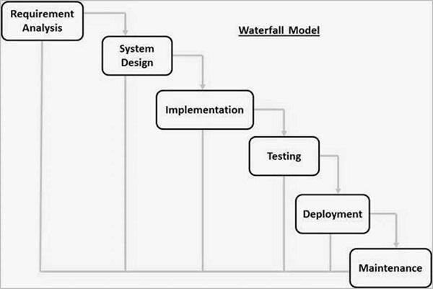The waterfall is a widely used SDLC model. The waterfall model is a continuous software development model in which development is seen as flowing steadily downwards (like a waterfall) through the steps of requirements analysis, design, implementation, testing (validation), integration, and maintenance. To begin, some certification techniques must be used at the end of each step to identify the end of one phase and the start of the next.

Figure 3.1. Waterfall Model

##### RAD Model

The Rapid Application Development (RAD) process is an adaptation of the waterfall model that aims to develop software in a short period of time. The RAD model is based on the idea that by using focus groups to gather system requirements, a better system can be developed in less time.

* + - * Business Modeling
      * Data Modeling
      * Process Modeling
      * Application Generation
      * Testing and Turnover

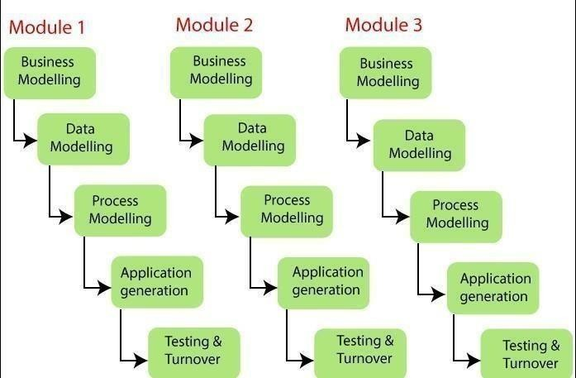

Figure 3.2. RAD Model

##### Spiral Model

The spiral model is a process model that is risk-driven. This SDLC model assists the group in implementing elements of one or more process models such as waterfall, incremental, waterfall, and so on. The spiral technique is a hybrid of rapid prototyping and concurrent designand development. Each spiral cycle begins with the identification of the cycle's objectives, the various alternatives for achieving the goals, and the constraints that exist. This is the cycle's first quadrant (upper-left quadrant).

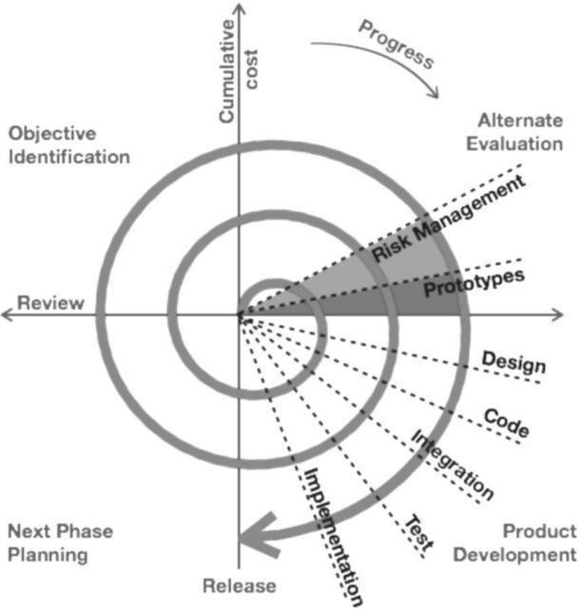

Figure 3.3. Spiral Model

##### Incremental Model

The incremental model does not stand alone. It must be a series of waterfall cycles. At the startof the project, the requirements are divided into groups. The SDLC model is used to develop software for each group. The SDLC process is repeated, with each release introducing new features until all requirements are met. Each cycle in this method serves as the maintenance phase for the previous software release.

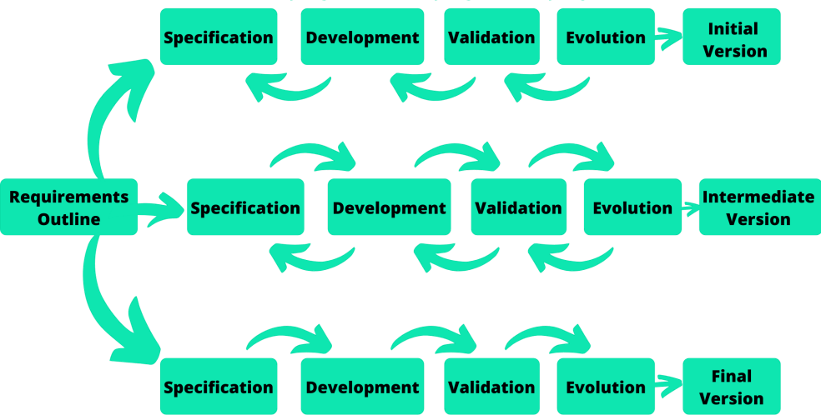

Figure 3.4. Incremental Mode

##### Model used in project: Prototype Model

* For our project we have used prototype model. The prototyping model starts with the requirements gathering. The developer and the user meet and define the purpose of the software, identify the needs, etc. A 'quick design' is then created. This design focuses on those aspects of the software that will be visible to the user. It then leads to the development of a prototype. The customer then checks the prototype, and any modifications or changes that are needed are made to the prototype. Looping takes place in this step, and better versions of the prototype are created. These are continuously shown to the user so that any new changes can be updated in the prototype. This process continue until the customer is satisfied with the system. Once a user is satisfied, the prototype is converted to the actual system with all considerations for quality and security.

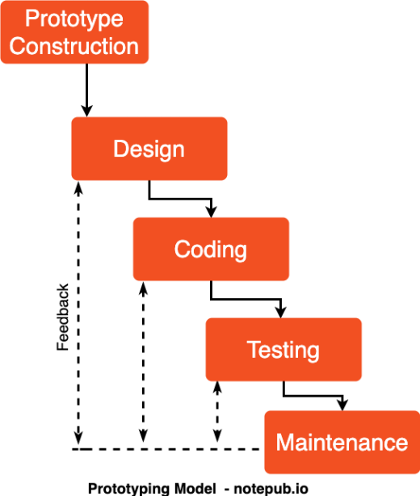

**Figure 4.6. Prototype Model (a)**

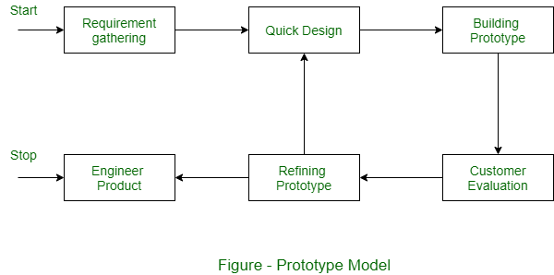

**Figure 4.6. Prototype Model (b)**

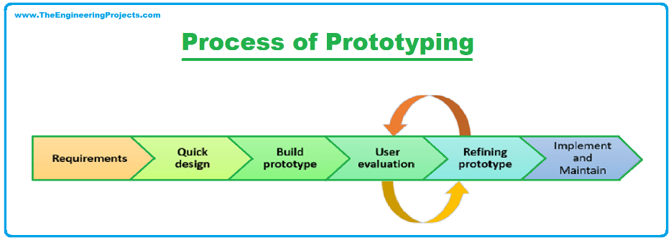

**Figure 4.6. Prototype Model (c)**

# CHAPTER 4

**SOFTWARE REQUIREMENT SPECIFICATION AND**

## **ANALYSIS**

###### Purpose

The purpose of KeyGuardian is to provide users with a robust and user-friendly platform for managing cryptographic keys and performing encryption and decryption operations efficiently. It aims to streamline the process of key management and cryptographic operations, thereby enhancing data security and user experience.

###### Scope

KeyGuardian goes beyond traditional encryption tools by offering a comprehensive solution that addresses the complexities of key management. It includes features such as automatic key generation, secure storage of keys in a default key folder, and seamless integration with cryptographic algorithms. The scope of KeyGuardian encompasses key generation, encryption, decryption, and key management functionalities.

###### Definitions, Acronyms, and Abbreviations

SRS: Software Requirements Specification

UI: User Interface

API: Application Programming Interface

#### FUNCTIONAL REQUIREMENTS

###### Data File System Access

* + - * KeyGuardian should have the access to generate/modify cryptographic keys, encrypted and/or decrypted file.
      * KeyGuardian should randomize they keys to enhance the security and robustness.

###### Key Generation

* + - * KeyGuardian should have the capability to generate cryptographic keys securely.
      * The key generation process should adhere to industry standards for cryptographic key generation.

###### Encryption and Decryption

* + - * KeyGuardian must support encryption and decryption of files and folders using cryptographic keys.
      * It should employ robust encryption algorithms such as Fernet to ensure data security.

###### Key Management:

* + - * Users should be able to manage cryptographic keys efficiently, including storing, retrieving, and deleting keys.
      * KeyGuardian should provide a default key folder where users can securely store their keys.

###### User Authentication

* + - * KeyGuardian should include user authentication mechanisms to ensure that only authorized users can access the application.
      * Authentication methods may include username/password authentication or integration with third-party authentication providers.

#### NON-FUNCTIONAL REQUIREMENTS

###### Security

* + - * KeyGuardian should implement encryption for data transmission to ensure secure communication between the user's device and the application server like Google Cloud.
      * It should enforce access control mechanisms to prevent unauthorized access to cryptographic keys and sensitive data.

###### Performance

* + - * KeyGuardian should provide fast response times for key generation, encryption, and decryption operations.
      * It should be able to handle multiple concurrent users without compromising performance.

###### Usability

* + - * KeyGuardian should have a user-friendly interface that is easy to navigate and understand.
      * It should provide clear instructions and guidance to users on how to perform key management and cryptographic operations.

###### Reliability

* + - * KeyGuardian should be reliable and available whenever users need to perform key management or cryptographic operations.
      * It should have mechanisms in place to handle errors and exceptions gracefully, ensuring uninterrupted service.

###### Compatibility

* + - * KeyGuardian should be compatible with a wide range of operating systems and devices, including Windows, macOS, and Linux.
      * It should support integration with other software applications and systems through APIs or other interfaces.

###### Scalability

* + - * KeyGuardian should be designed to scale horizontally to accommodate an increasing number of users and data volumes.
      * It should be able to handle spikes in user activity without experiencing performance degradation.

#### DESIGN CONSTRAINTS

###### Technology Stack

* + - * Frontend: Python CUI
      * Backend: Python with Fernet framework
      * Database: SQLite

#### CONCLUSION

The Software Requirement Specification and Analysis for KeyGuardian outline the functional and non-functional requirements, design constraints, and critical aspects of the system. This document serves as a blueprint for the development team to ensure the successful implementation of KeyGuardian as a secure and user-friendly cryptographic key management solution.

# CHAPTER 5 RISK ASSESSMENT

#### PROJECT RISKS

###### Technical Complexity

Likelihood: High

Consequence: Delayed project timeline, increased development costs.

Risk Avoidance: Conduct thorough technology feasibility studies before project initiation.

Risk Reduction: Employ skilled developers with experience in the chosen technology stack.

###### Integration Challenges

Likelihood: Medium

Consequence: System malfunctions, data inconsistencies.

Risk Avoidance: Conduct comprehensive testing during integration phases.

Risk Reduction: Use standardized data exchange formats and protocols.

###### User Adoption

Likelihood: Medium

Risk Avoidance: Conduct user feedback sessions during development.

Risk Reduction: Implement an intuitive user interface, provide user training materials.

#### SECURITY AND COMPLIANCE RISKS

###### Data Breach

Likelihood: Medium

Consequence: Compromised user data, legal penalties, damage to reputation.

Risk Avoidance: Implement strong encryption standards for data storage and transmission.

Risk Reduction: Regular security audits and penetration testing to identify and address vulnerabilities.

###### Regulatory Compliance Violation

Likelihood: Medium

Consequence: Legal penalties, damage to reputation.

Risk Avoidance: Ensure compliance with relevant regulations like GDPR.

Risk Reduction: Regularly update security policies and procedures to align with regulatory changes.

#### OPERATIONAL RISKS

###### Downtime

Likelihood: Medium

Consequence: Disrupted services, user frustration.

Risk Avoidance: Implement redundant server infrastructure.

Risk Reduction: Regular maintenance during low usage periods.

###### Insufficient Scalability

Likelihood: High

Consequence: Poor system performance, frustrated users.

Risk Avoidance: Conduct scalability testing during development

Risk Reduction: Implement elastic scaling solutions.

#### EXTERNAL RISKS

###### Regulatory Changes

Likelihood: Low

Consequence: Changes in compliance requirements, project delays.

Risk Avoidance: Stay informed about healthcare regulations.

Risk Transfer: Regularly consult legal experts for compliance updates.

###### Third-Party Service Reliability

Likelihood: Medium

Consequence: Service interruptions, impact on functionality.

Risk Avoidance: Select reputable third-party services.

Risk Reduction: Implement fallback mechanisms for critical functionalities.

###### Market Competition

Likelihood: Medium

Consequence: Reduced market share, potential loss of users.

Risk Avoidance: Conduct thorough market research and competitive analysis.

Risk Reduction: Continuously innovate and improve KeyGuardian’s features to maintain a competitive edge.

#### RISK MITIGATION STRATEGIES

###### Risk Mitigation Planning

Risk Avoidance: Identify and eliminate risks at the early stages of project planning.

Risk Transfer: Utilize insurance and legal mechanisms to transfer specific risks.

Risk Reduction: Implement measures to minimize the impact or likelihood of identified risks.

###### Continuous Monitoring and Evaluation

Establish regular risk assessment reviews throughout the project lifecycle. Monitor external factors, such as changes in regulations, and adjust risk strategies accordingly.

###### Contingency Planning

Develop contingency plans for high-impact risks, ensuring swift responses to mitigate consequences.

Maintain a comprehensive disaster recovery plan in case of major system failures.

## **CHAPTER 6**

## **DATA FLOW DIAGRAM**

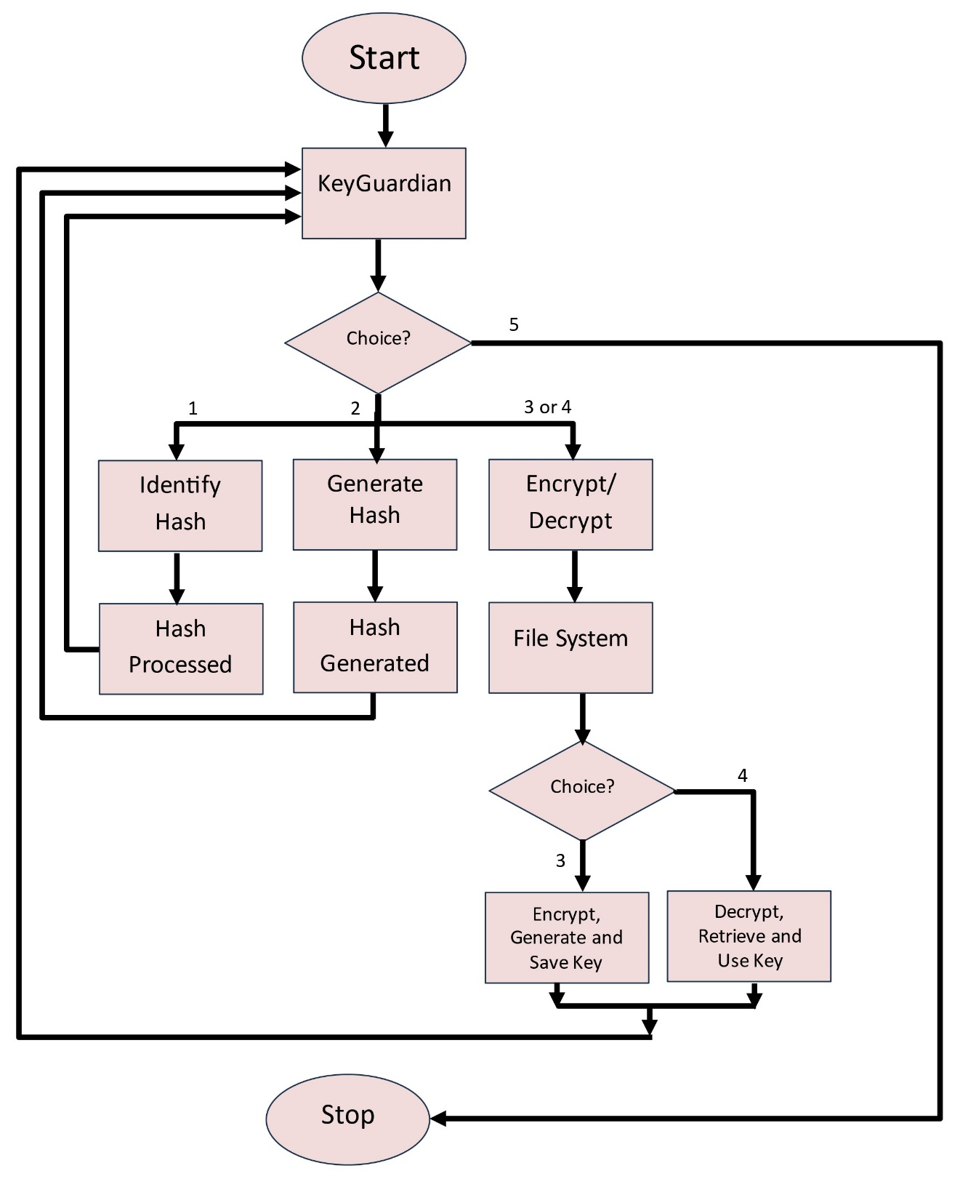

## **CHAPTER 7**

## **SOFTWARE FEATURES**

* Encryption and Decryption: Provide robust encryption and decryption capabilities using advanced algorithms to secure user data.
* Key Management: Automatically manage cryptographic keys with a default key folder, simplifying the key handling process for users.
* Hashing Functions: Implement various hashing algorithms (e.g., SHA-256, MD5) for data integrity verification and other cryptographic purposes.
* Compression Support: Integrate zlib for data compression, allowing users to efficiently compress and decompress data files.
* Integrated Python Environment: Offer an embedded Python environment for users to execute their encryption, decryption, and hashing operations seamlessly.
* User-Friendly Command-Line Interface: Provide a comprehensive and intuitive command-line interface to facilitate easy interaction with KeyGuardian’s features.
* Multi-Algorithm Support: Support multiple encryption and hashing algorithms, giving users the flexibility to choose the most suitable method for their needs.
* Access Control: Implement role-based access control to ensure secure usage and management of cryptographic keys and data.
* Data Integrity Checks: Enable automatic integrity checks to verify the authenticity and consistency of data before and after processing.
* Real-Time Performance Metrics: Display detailed performance metrics for encryption, decryption, and hashing operations, including execution time and resource usage.
* Interactive Tutorials: Provide step-by-step tutorials and documentation to help users understand and effectively use KeyGuardian’s features.
* Cross-Platform Compatibility: Ensure KeyGuardian is compatible with various operating systems, including Windows, macOS, and Linux.
* Secure Storage Solutions: Offer options for secure, decentralized storage of encrypted data to protect against unauthorized access.
* Regular Updates and Support: Deliver regular updates to introduce new features, improve security, and provide technical support for users.
* Community Integration: Facilitate a user community for sharing best practices, tips, and collaborative problem-solving.
* Modular Design: Use a modular codebase to allow for easy future enhancements and the addition of new cryptographic algorithms.
* Automated Key Rotation: Include a feature for automatic key rotation to enhance security and minimize the risk of key compromise.
* Customizable Settings: Allow users to customize various settings, such as encryption parameters and key storage preferences, to fit their specific requirements.
* Audit Logging: Implement audit logging to track user actions and operations within the tool for security and accountability purposes.
* Mobile Compatibility: Ensure the interface is responsive and usable on mobile devices, enabling users to manage their cryptographic tasks on the go.
* Integration with Existing Tools: Support integration with existing tools and workflows to streamline the use of KeyGuardian in diverse environments.
* Offline Functionality: Provide offline functionality to enable users to perform encryption and decryption tasks without an internet connection.
* Extensive Documentation: Offer comprehensive documentation covering all features, usage guidelines, and troubleshooting tips.
* Multi-Language Support: Support multiple languages in the interface to cater to a global user base.
* Version Control for Keys: Include version control for cryptographic keys, allowing users to manage and revert key changes as needed.
* Security Audits: Conduct regular security audits and provide reports to ensure ongoing protection against emerging threats.

## **CHAPTER 8**

### **TESTING AND EVALUATIONS**

1. Unit Testing for Encryption, Decryption, and Hashing:
   * Explanation: Unit tests verify individual components such as encryption, decryption, and hashing functions to ensure their correctness and functionality.
   * Example: Writing test cases to validate encryption and decryption operations using various algorithms (e.g., AES, RSA) and hashing functions (e.g., SHA-256, MD5). Ensuring that encrypted data can be correctly decrypted back to its original form and that hashing functions produce consistent outputs for identical inputs.
2. Integration Testing for Key Management and Data Handling:
   * Explanation: Integration tests ensure that different components interact seamlessly Explanation: Integration tests ensure that different components interact seamlessly within the system.
   * Example: Creating tests to validate that the key management system correctly stores, retrieves, and rotates keys, and that encryption/decryption operations using these keys function correctly. Testing scenarios where keys are auto-generated and securely stored, ensuring that subsequent decryption operations with stored keys produce accurate results.
3. System Testing for Command Execution and Input Handling:
   * Explanation: System tests evaluate the behavior of the entire system, including user interactions and command execution.
   * Example: Simulating command-line inputs such as encryption, decryption, and hashing commands, and verifying that the tool executes them correctly. Testing scenarios where users perform complex sequences of operations, ensuring that the system handles them accurately and without errors.
4. Performance Testing for Encryption and Decryption Efficiency:
   * Explanation: Performance tests assess the speed and efficiency of encryption and decryption operations under different conditions.
   * Example: Measuring the time complexity of encryption and decryption algorithms for various data sizes and analyzing the impact of input size on performance. Ensuring that cryptographic operations maintain acceptable performance levels even with large datasets and multiple concurrent operations.
5. User Acceptance Testing (UAT) for UTF-8 Enabled Terminals:
   * Explanation: Performance tests assess the speed and efficiency of encryption and decryption operations under different conditions.
   * Example: Involving stakeholders or target users to interact with KeyGuardian in UTF-8 enabled terminals, performing tasks like encrypting, decrypting, and hashing data. Gathering feedback on the clarity of instructions, ease of use, and overall user experience in various terminal environments.
6. Regression Testing for Cryptographic Algorithm Modifications:
   * Explanation: Regression tests verify that recent changes to the codebase have not introduced new defects or affected existing functionalities.
   * Example: After modifying existing encryption algorithms or introducing new features, running regression tests to ensure that encryption, decryption, and hashing functionalities still produce correct results. Ensuring that changes to cryptographic algorithms do not adversely affect the performance and accuracy of existing operations.
7. Security Testing for Input Validation:
   * Explanation: Security tests identify vulnerabilities and ensure the protection of sensitive data.
   * Example: Testing command-line inputs for proper validation to prevent security risks such as command injection attacks. Ensuring that all inputs are sanitized to prevent potential security threats, and verifying that the system can handle malicious inputs without compromising security.

## **CHAPTER 9**

## **PROJECT SNAPSHOTS**

* 1. **MAIN MENU**

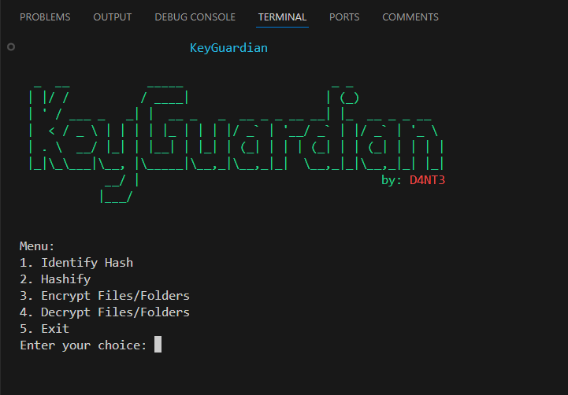

### 

### Fig 9.1 Main Menu

## **IDENTIFY HASH PAGE**

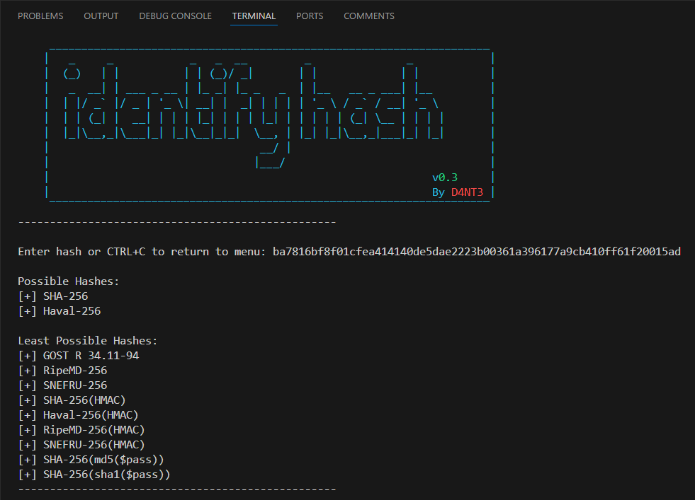

### Fig 9.2 Identify Hash Page

### **CREATE HASH PAGE**

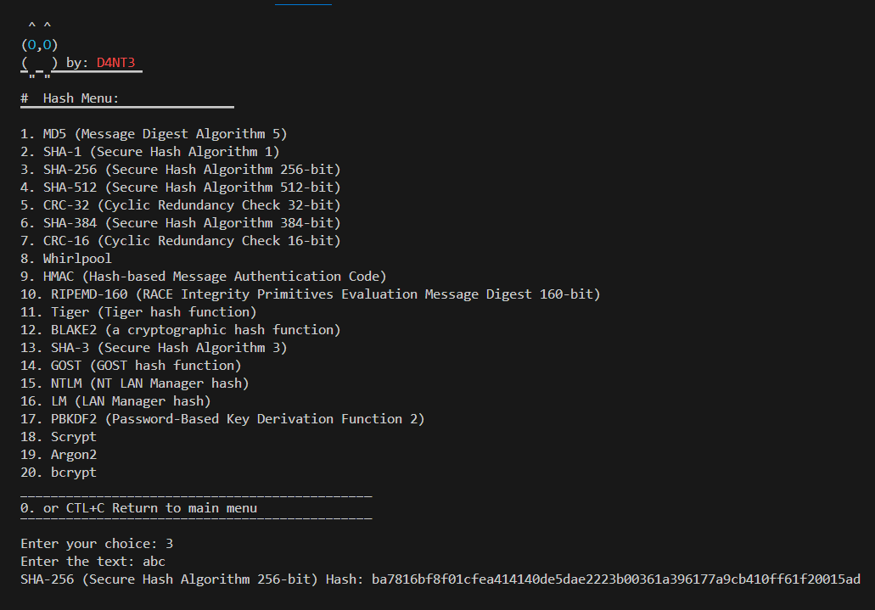

Fig 9.3 Create Hash Page

**9.4 ENCRYPT FILE/FOLDER PAGE**

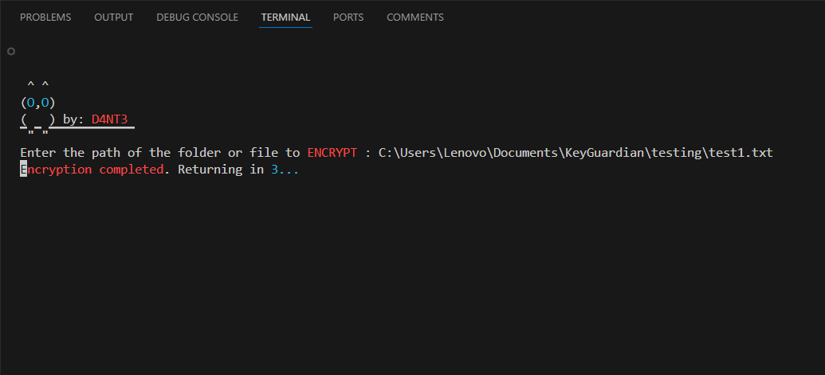

Fig 9.4 Encrypt File/Folder Page

### **9.5** **TEST FILE BEFORE ENCRYPTION**

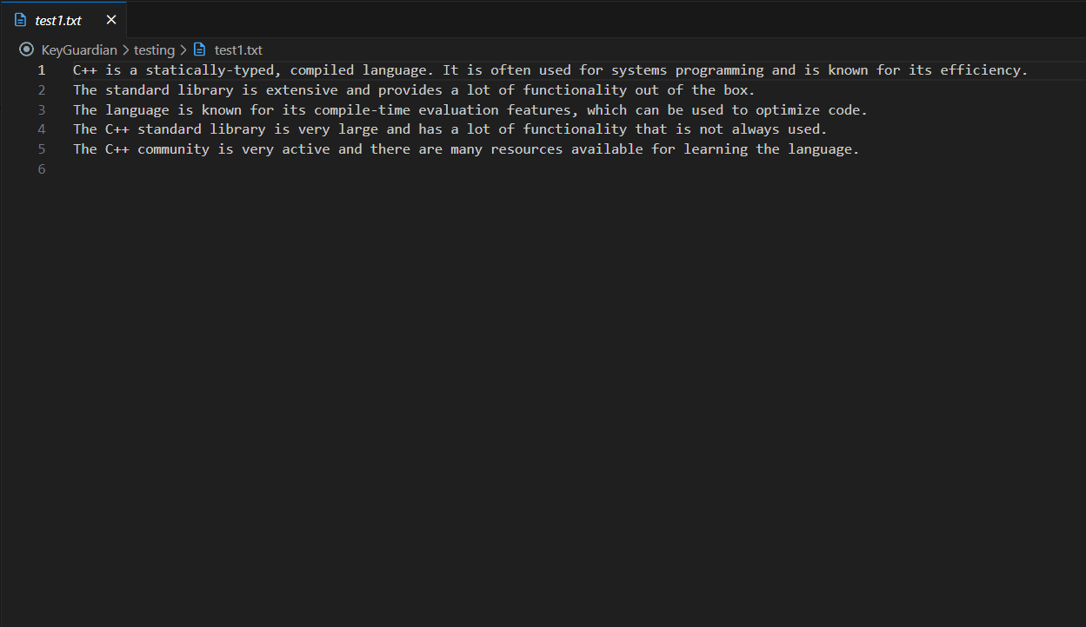

Fig 9. Test File before Encryption

**9.6 TEST FILE AFTER ENCRYPTION**

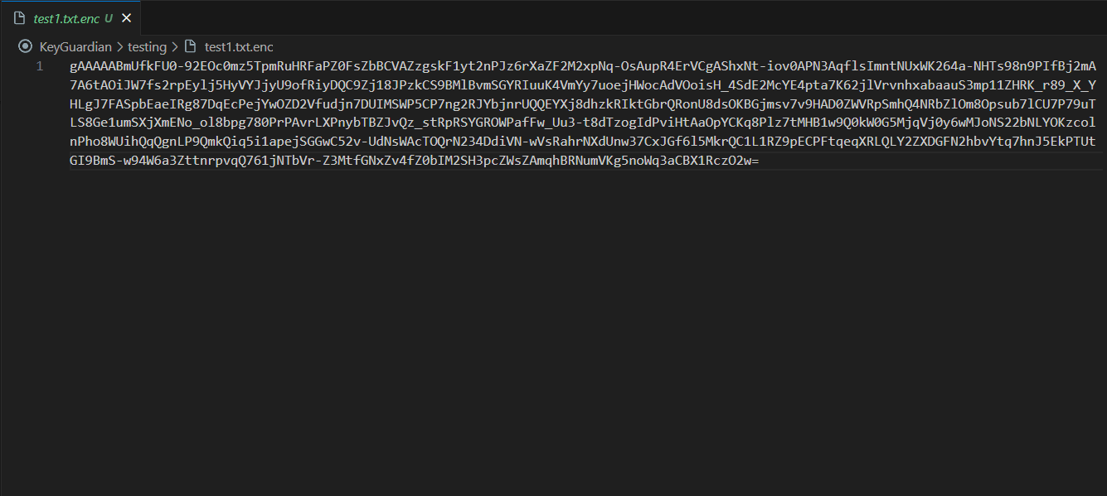

Fig 9.6 Test File after Encryption

**9.7 DECRYPT FILE/FOLDER PAGE**

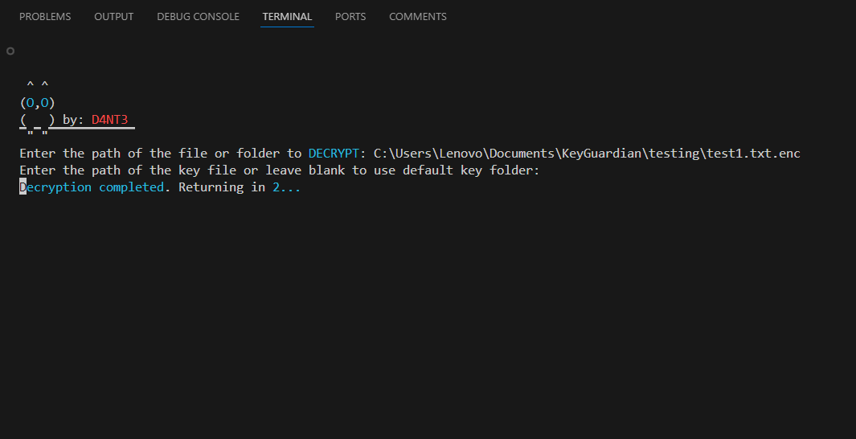

Fig 9.7 Encrypt File/Folder Page

**9.8 FILE BEFORE DECRYPTION**



Fig 9.8 File Before Decryption

**9.9 File After Decryption**



Fig 9.9 File After Decryption

**9.10 EXIT OPTION**

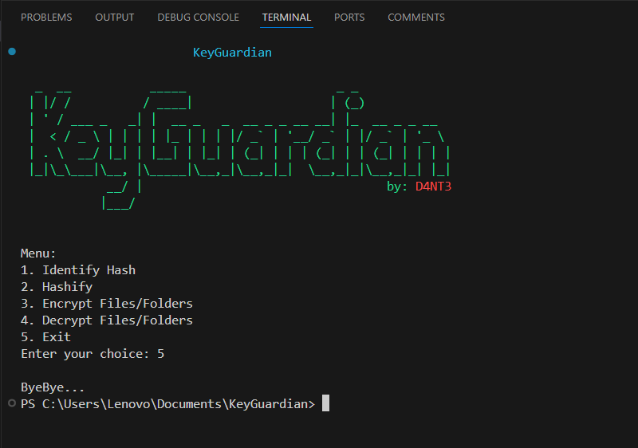

Fig 9.10 Last option Exit

## **CHAPTER 10**

### **LIMITATION**

* + 1. Command Line Interface Complexity:

Explanation: The reliance on a command line interface (CLI) for all interactions might pose a barrier for users unfamiliar with CLI environments.

Impact: Users with limited technical expertise may find it challenging to utilize KeyGuardian's features effectively.

Mitigation: Provide comprehensive user manuals, tutorials, and example commands to facilitate learning. Consider developing a graphical user interface (GUI) as an alternative.

* + 1. Command Injection Vulnerability:

Explanation: Being a CLI tool, KeyGuardian is susceptible to command injection attacks if user inputs are not properly validated and sanitized.

Impact: Potential security risks, including unauthorized access and data breaches.

Mitigation: Implement robust input validation and sanitization techniques. Conduct regular security audits and penetration testing to identify and address vulnerabilities.

* + 1. Dependency on Python Environment:

Explanation: KeyGuardian now relies entirely on the Python programming language, which may limit its compatibility with environments where Python is not readily available or supported.

Impact: Users may face difficulties in installing and running KeyGuardian if their systems lack the necessary Python environment.

Mitigation: Provide detailed installation instructions and dependencies. Consider packaging KeyGuardian with necessary Python binaries for easier installation.

* + 1. Performance Overheads:

Explanation: The performance of encryption and decryption operations can vary significantly based on system specifications and data size.

Impact: Users with lower-end hardware may experience slower processing times, affecting their workflow efficiency.

Mitigation: Optimize the code for performance, provide options to adjust encryption settings for faster processing, and offer guidelines for improving performance on various systems.

* + 1. Data Integrity and Backup:

Explanation: Ensuring data integrity during encryption and decryption processes is crucial, as any corruption can lead to data loss.

Impact: Users risk losing critical data if integrity checks and backups are not adequately managed.

Mitigation: Implement data integrity checks and automatic backup features. Provide guidelines for regular manual backups and data recovery procedures.

* + 1. Integration with Existing Systems:

Explanation: Integrating KeyGuardian with other security tools and systems might pose compatibility issues.

Impact: Users may encounter difficulties in seamlessly incorporating KeyGuardian into their existing security workflows.

Mitigation: Develop comprehensive integration guides and support for popular security tools. Ensure KeyGuardian's output formats are compatible with other systems.

* + 1. Scalability Challenges:

Explanation: The scalability of KeyGuardian's operations, particularly with large datasets or high-frequency usage, remains a concern.

Impact: As user demand grows, the tool may experience performance bottlenecks or system overloads.

Mitigation: Conduct scalability testing and optimize the architecture to handle increased loads. Implement load balancing and distributed processing techniques where applicable.

* + 1. Lack of Real-Time Collaboration Features:

Explanation: KeyGuardian, being a CLI tool, lacks features that support real-time collaboration between users.

Impact: Users working in teams may find it difficult to collaborate efficiently without integrated collaboration tools.

Mitigation: Explore the possibility of integrating version control systems or collaborative platforms. Provide guidelines for collaborative workflows using external tools.

* + 1. User Engagement and Training:

Explanation: Sustaining user engagement and ensuring users are adequately trained to use KeyGuardian effectively can be challenging.

Impact: Users may not fully utilize all features or may abandon the tool due to complexity.

Mitigation: Offer regular training sessions, webinars, and an active user community forum. Continuously update documentation and provide responsive user support.

* + 1. Cross-Platform Compatibility:

Explanation: Ensuring KeyGuardian works consistently across different operating systems can be complex.

Impact: Users on less common operating systems might face compatibility issues or reduced functionality.

Mitigation: Perform thorough testing on all major operating systems and provide platform-specific installation packages and instructions. Consider user feedback to identify and address platform-specific issues.

## **CHAPTER 11**

### **FUTURE SCOPE**

1. User Login and Multi-User Control:
   * Explanation: Introduce a user authentication and login system to manage multiple users securely.
   * Implementation: Develop a robust authentication mechanism, including username and password protection, and potentially integrating two-factor authentication (2FA) for added security.
   * Benefit: Enables personalized user experiences, user-specific settings, and secure access control for multiple users.
2. Adding Extra Cryptographic Methods:
   * Explanation: Expand the suite of cryptographic methods available for file and folder encryption.
   * Implementation: Include advanced encryption algorithms such as AES-256, RSA, and elliptic-curve cryptography (ECC).
   * Benefit: Provides users with a range of encryption options, enhancing security and flexibility in protecting their data.
3. Support for Steganography:
   * Explanation: Incorporate steganography techniques to hide data within files.
   * Implementation: Develop features that allow users to embed hidden messages within images, audio files, or other multimedia formats.
   * Benefit: Adds an additional layer of security for sensitive information, making it harder for unauthorized parties to detect hidden data.
4. API Support for Web Linking:
   * Explanation: Develop an API to enable integration with web applications and other online services.
   * Implementation: Create RESTful APIs that allow external applications to interact with KeyGuardian, facilitating operations such as file encryption, user authentication, and data retrieval.
   * Benefit: Enhances the tool's interoperability, allowing it to be part of a larger ecosystem of security tools and services.
5. Enhancing the Command Line Interface:
   * Explanation: Improve the usability and functionality of the CLI to provide a better user experience.
   * Implementation: Add command auto-completion, better error handling, and more detailed help commands.
   * Benefit: Makes the CLI more user-friendly and accessible, especially for users who may not be familiar with command line operations.
6. Improving Performance and Scalability:
   * Explanation: Enhance the performance and scalability of KeyGuardian to handle larger datasets and more simultaneous users.
   * Implementation: Optimize algorithms, implement caching strategies, and conduct performance benchmarking.
   * Benefit: Ensures that the tool remains efficient and responsive even as the user base and data size grow.
7. Enhancing Data Privacy and Security:
   * Explanation: Strengthen measures to protect user data and ensure compliance with data protection regulations.
   * Implementation: Regularly update encryption protocols, conduct security audits, and ensure compliance with regulations such as GDPR and CCPA.
   * Benefit: Provides users with confidence that their data is secure and their privacy is protected.
8. Continued Research and Development:
   * Explanation: Engage in ongoing research and collaboration to keep KeyGuardian at the forefront of technology.
   * Implementation: Collaborate with academic institutions, industry experts, and user communities to incorporate the latest advancements in cryptography and data security.
   * Benefit: Ensures that KeyGuardian evolves continuously, incorporating cutting-edge practices and maintaining its relevance and effectiveness.
9. Feedback and Iterative Improvement:
   * Explanation: Actively seek and integrate user feedback to improve KeyGuardian.
   * Implementation: Use surveys, user analytics, and direct feedback channels to gather insights. Implement a structured process for integrating this feedback into regular updates and enhancements.
   * Benefit: Ensures that KeyGuardian remains user-centric, responsive to user needs, and continuously improving based on real-world usage.

### **CONCLUSION**

Considering the future trajectory of this innovative platform, it's evident that its impact could extend far beyond individual learners. By bridging the gap between theoretical knowledge and practical application, the platform has the potential to transform the way data structures are taught and learned in educational institutions worldwide.

One of its key strengths lies in its adaptability and scalability. As it evolves, the platform can be tailored to meet the specific needs of different educational settings, from K-12 schools to higher education institutions and professional development programs. This adaptability opens up a wide range of possibilities for integrating the platform into existing curricula and learning frameworks, thereby enhancing the effectiveness of data structures education across diverse contexts.

Furthermore, the platform's emphasis on collaboration and community engagement offers a unique opportunity to foster a culture of learning and knowledge sharing among users. By providing tools for collaboration, such as discussion forums, group projects, and peer review features, the platform can facilitate meaningful interactions and foster a sense of belonging within the learning community.

In addition to its educational impact, the platform also has the potential to drive innovation in the field of data structures and algorithms. By providing a platform for users to experiment with new ideas, explore innovative solutions, and share their findings with others, the platform can contribute to the advancement of knowledge in this critical area of computer science.

Overall, the future of this platform is promising, with the potential to make a lasting impact on the way data structures are taught, learned, and applied. By embracing innovation, collaboration, and inclusivity, the platform has the opportunity to empower learners of all backgrounds and abilities to excel in the field of data structures and beyond

# References

[1] Dhruv Sharma, C. Fancy, "Cloud Storage Security using Firebase and Fernet Encryption," 2022. (<http://dx.doi.org/10.14445/22315381/IJETT-V70I9P237>)

[2] El Gaabouri Ismail, Chahboun Asaad, and Raissouni Naoufal, "Fernet Symmetric Encryption method to gather MQTT E2E secure communications for IOT Devices," 2020. (<https://www.researchgate.net/publication/349768295>)

[3] Aryo P. Pinanditoa, Agi Putra Kharismab, Eriq Muhammad Adams Jonemarob, "Architectural Design of Representational State Transfer Application Programming Interface

with Application-Level Base64-Encoding and Zlib Data Compression," 2023. (<https://doi.org/10.25126/jitecs.202383619>)

[4] Joshua Calvin Kurniawan, Adhitya Nugraha, Ariel Immanuel Prayogo, The Fandy Novanto, "Improving Data Embedding Capacity in LSB Steganography Utilizing LSB2 and Zlib Compression," 2024. ( <http://dx.doi.org/10.33395/sinkron.v9i1.13185>)

[5] Prof. Shweta Sabnis, Prof. Pavan Mitragotri, "The Next Frontier of Security: Homomorphic Encryption in Action," 2024.(<https://www.ijraset.com/best-journal/the-next-frontier-of-security-homomorphic-encryption-in-action>)

[6] Bharati A. Patil, Prajakta R. Toke, Sharyu S. Naiknavare, "Research on Various Cryptography Techniques," 2024. ( <http://dx.doi.org/10.32628/CSEIT2410290>)

[7] K. Obulesh, R. Laxmi Prasana, S. Lakshmi Supraja, Sameena Begum, "A Fernet Based Lightweight Cryptography Adopted Enhancing Certificate Validation through Blockchain Technology," 2024. (<https://doi.org/10.46243/jst.2024.v9.i1.pp21-29>)

[8] Aishwarya Nawal, Harish Soni, Shweta Arewar, Varshita Gangadhara, "Secure File Storage On Cloud Using Hybrid Cryptography," 2021. (<https://doi.org/10.48175/IJARSCT-1101>)

[9] Singh, M., & Malik, A. (2024). Multi-hop routing protocol in SDN-Based wireless sensor network. In CRC Press eBooks (pp. 121–141). (<https://doi.org/10.1201/9781003432869-8>)

[10] Singh, M., Gupta, M., Sharma, A., Jain, P., & Aggarwal, P. (2023). Role of deep learning in the healthcare industry: Limitations, challenges, and future scope. In BENTHAM SCIENCE PUBLISHERS eBooks (pp. 1– 22). (<https://doi.org/10.2174/9789815080230123020003>)

[11] Gupta, M., Singh, M., Sharma, A., Sukhija, N., Aggarwal, P., & Jain, P. (2023). Unification of machine learning and blockchain technology in the healthcare industry. In Institution of Engineering and Technology eBooks (pp. 185–206). (<https://doi.org/10.1049/pbhe041e_ch6>)

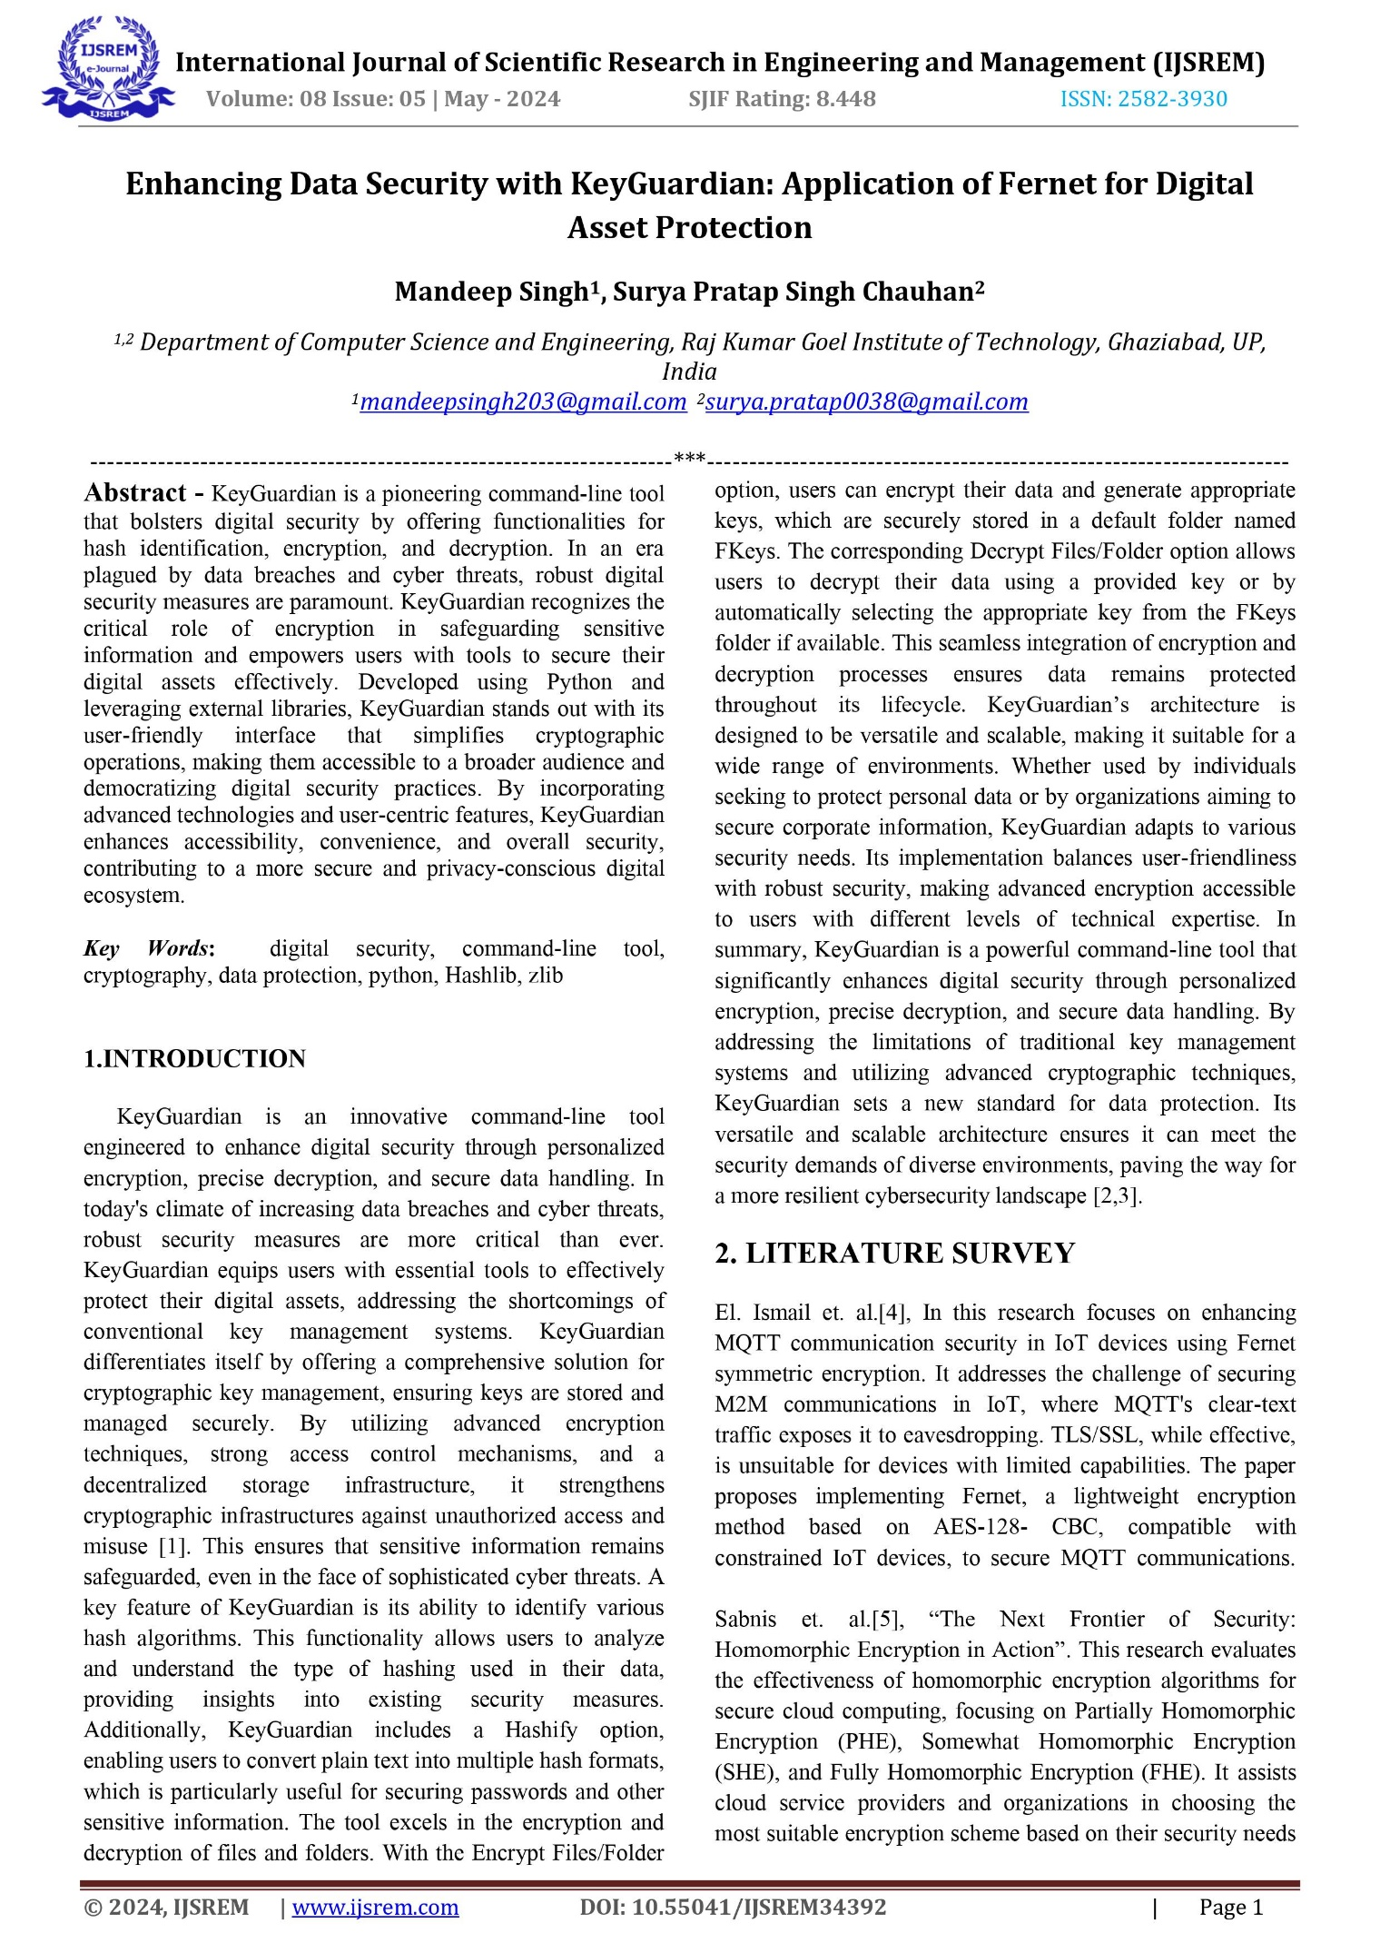

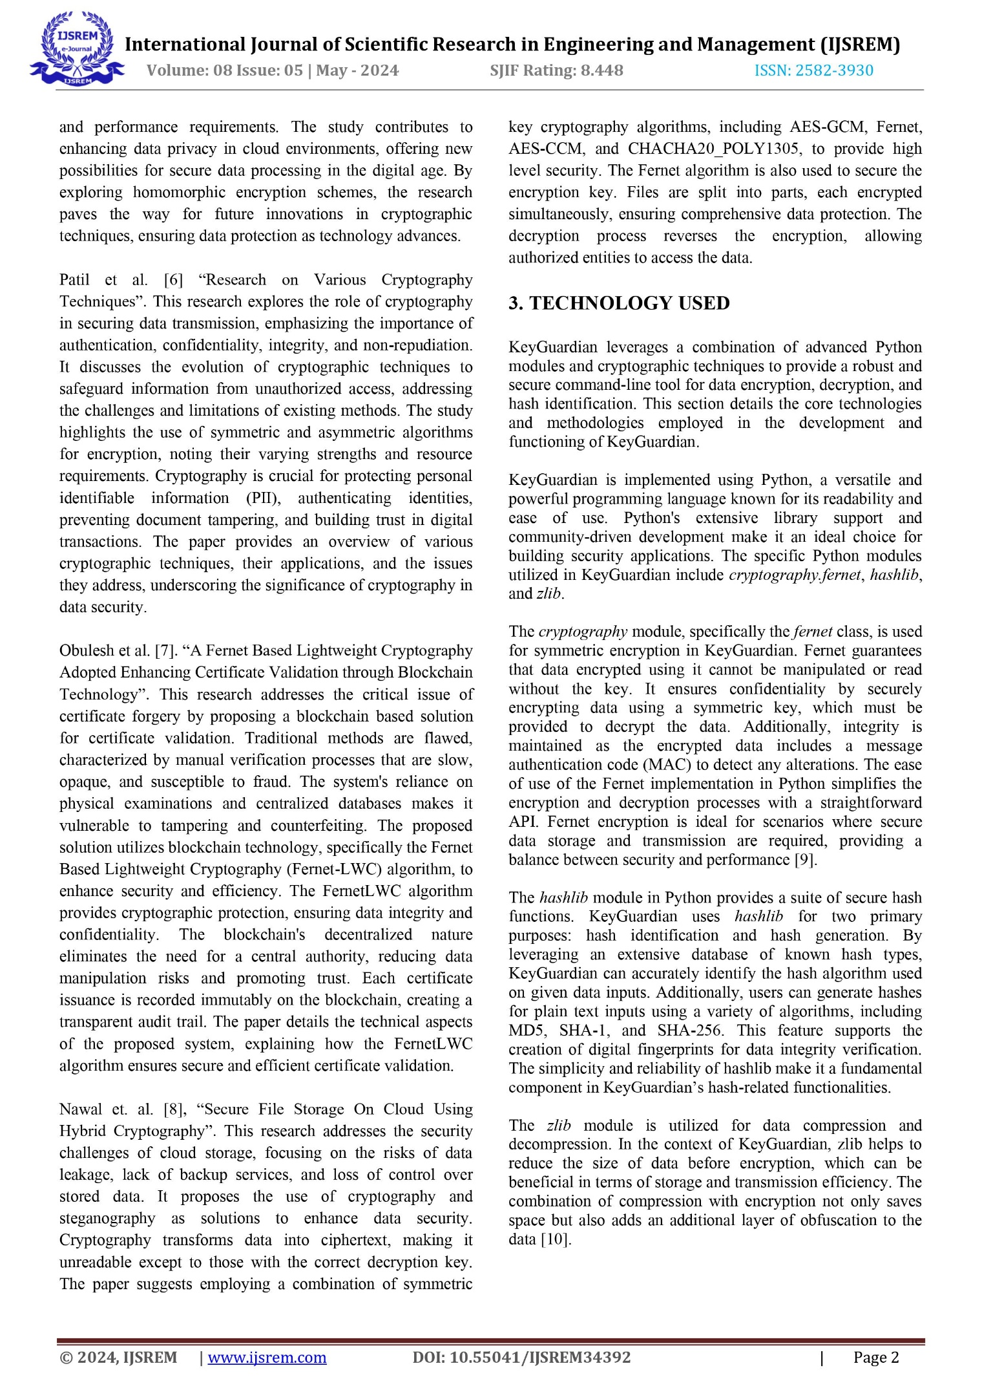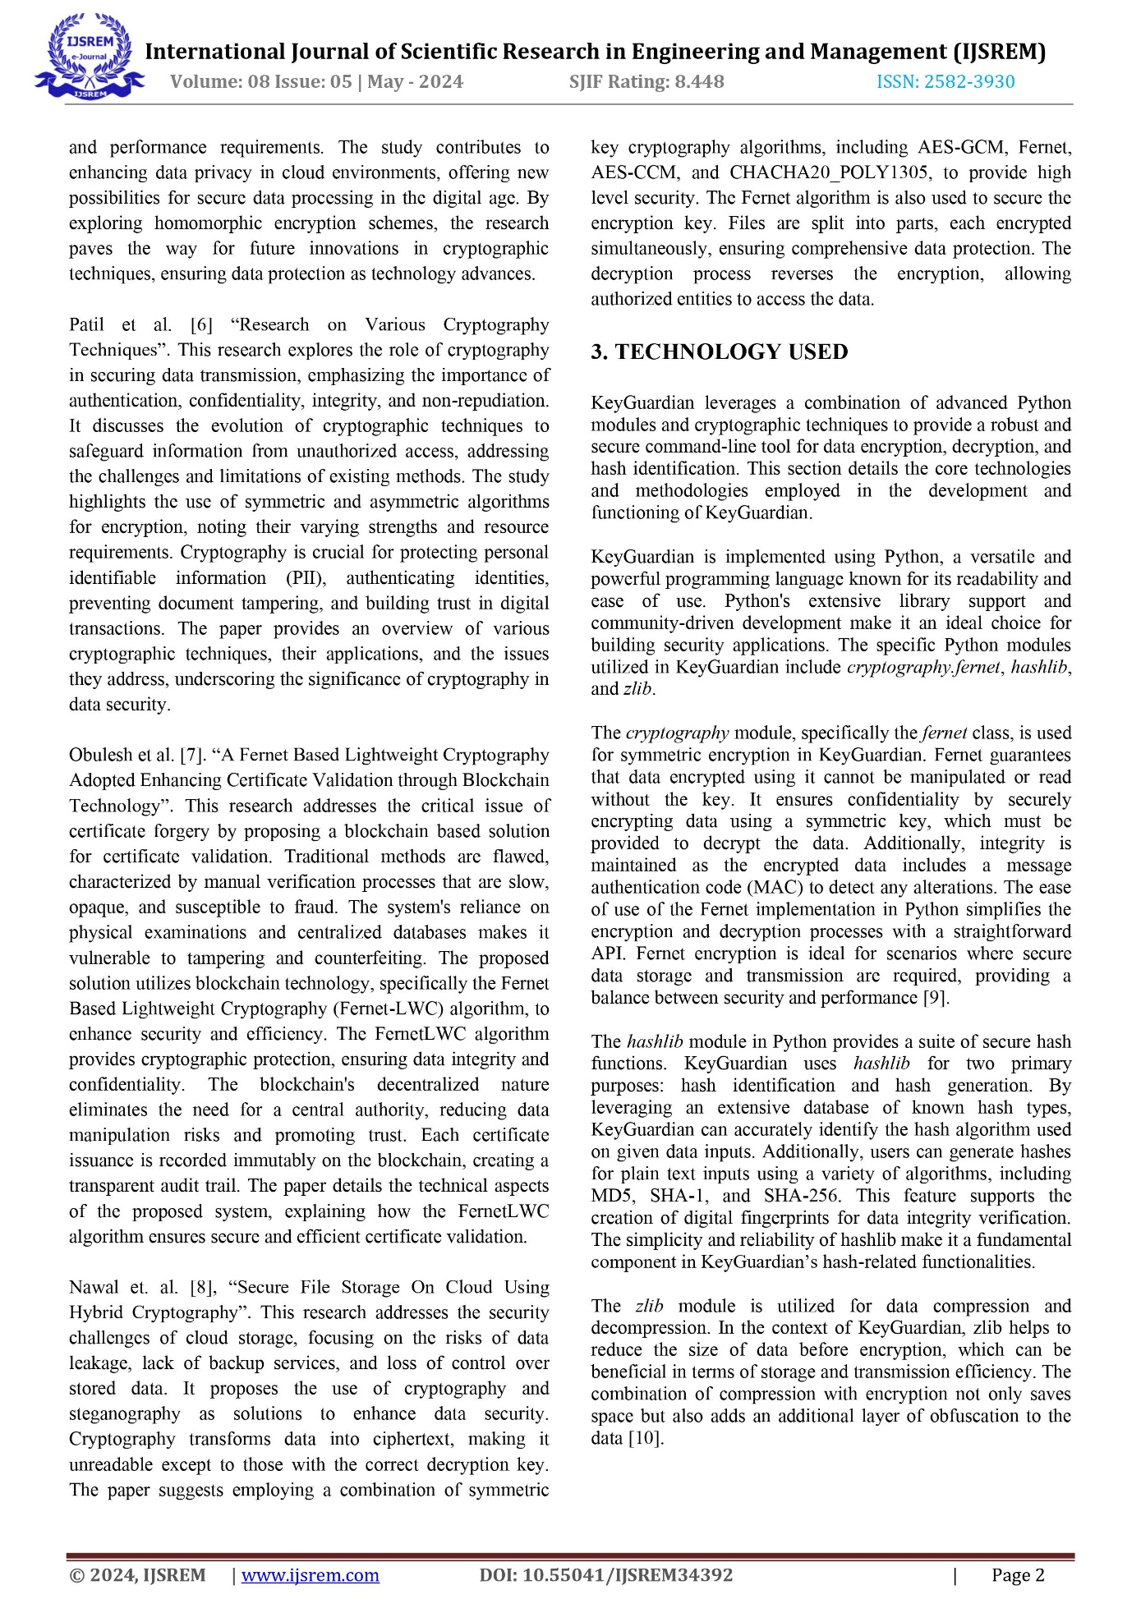

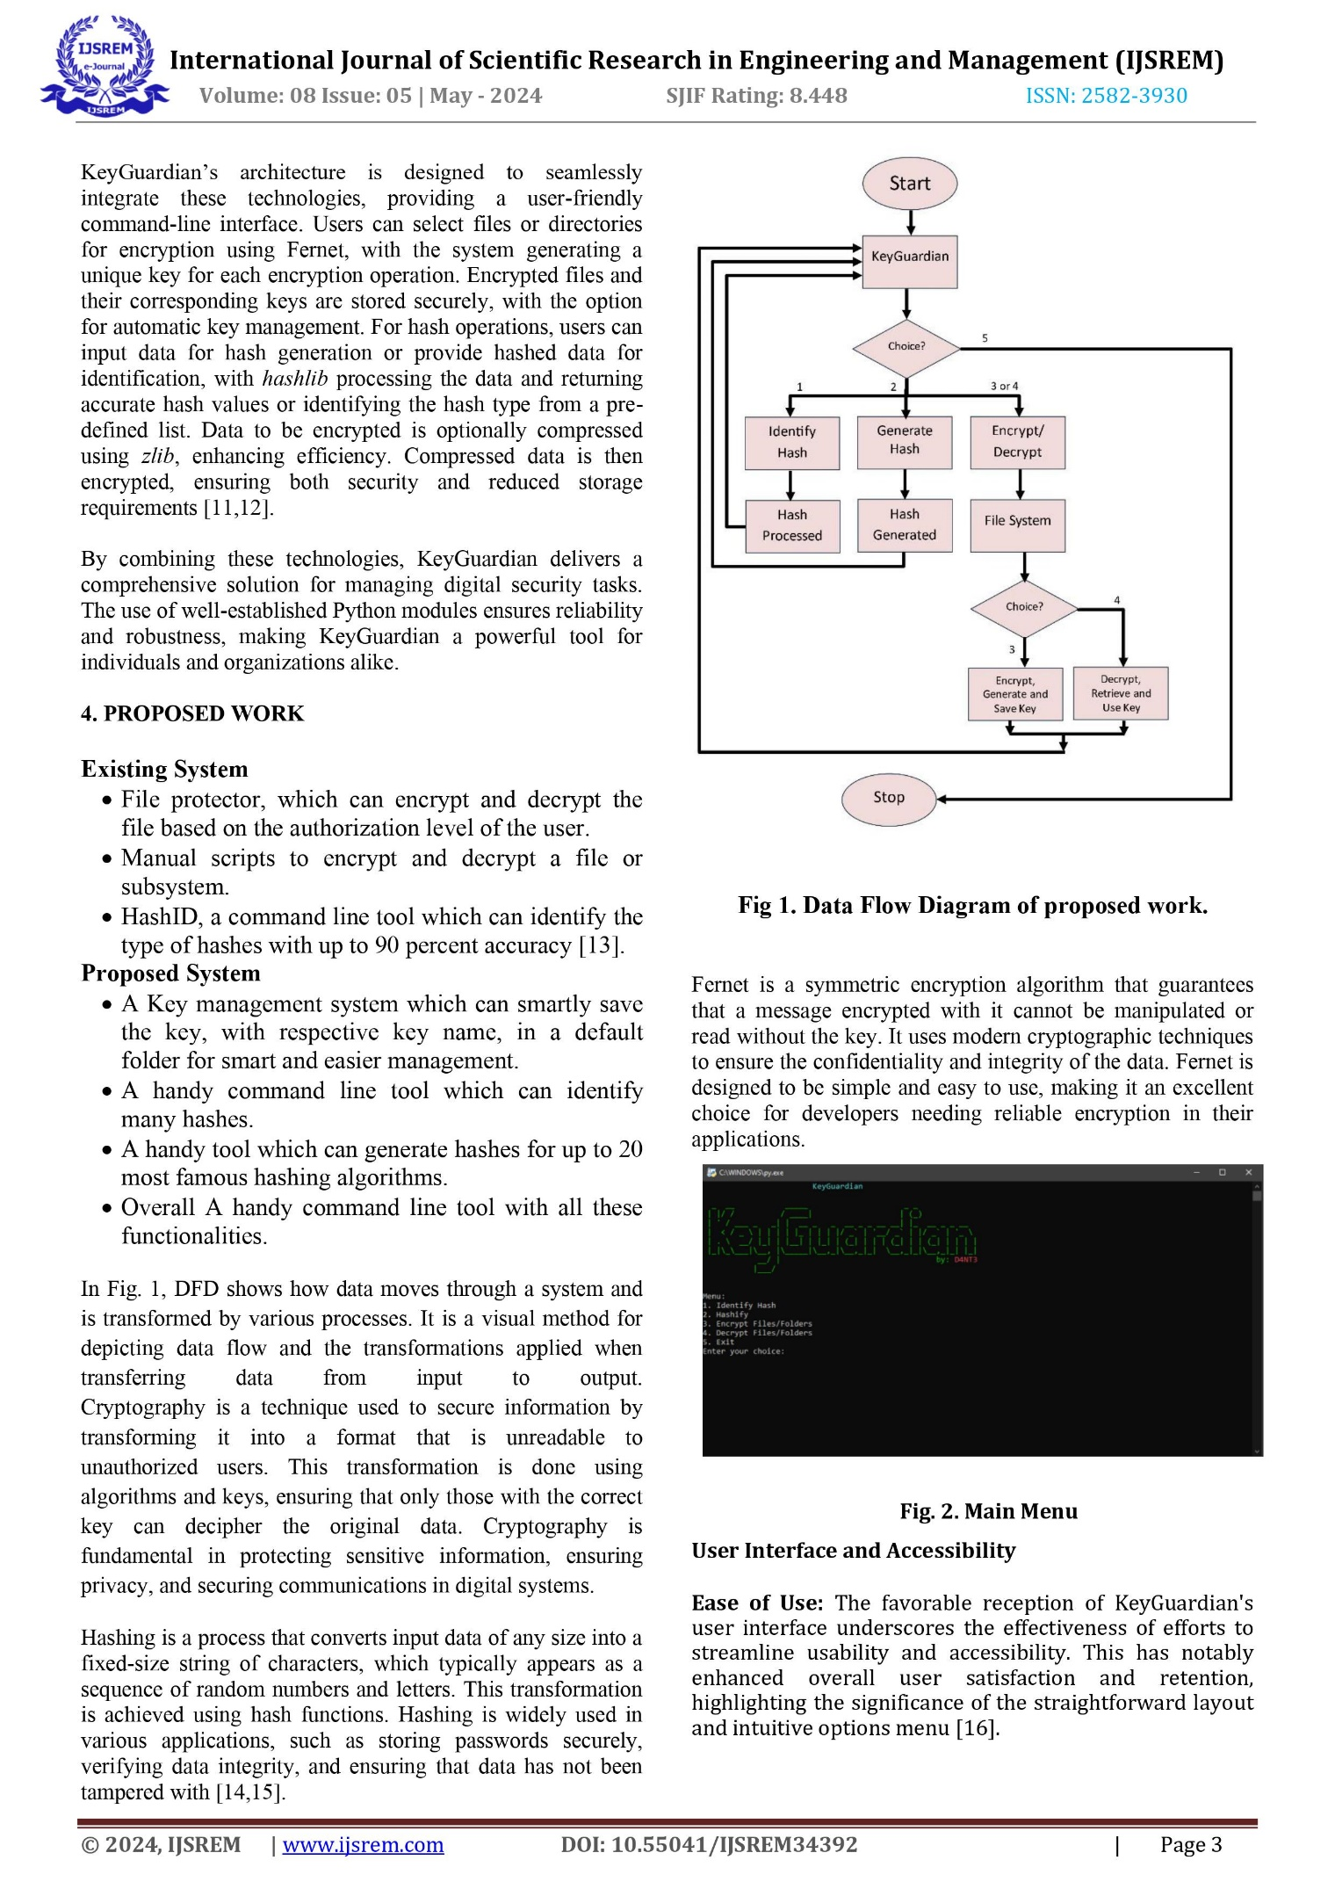

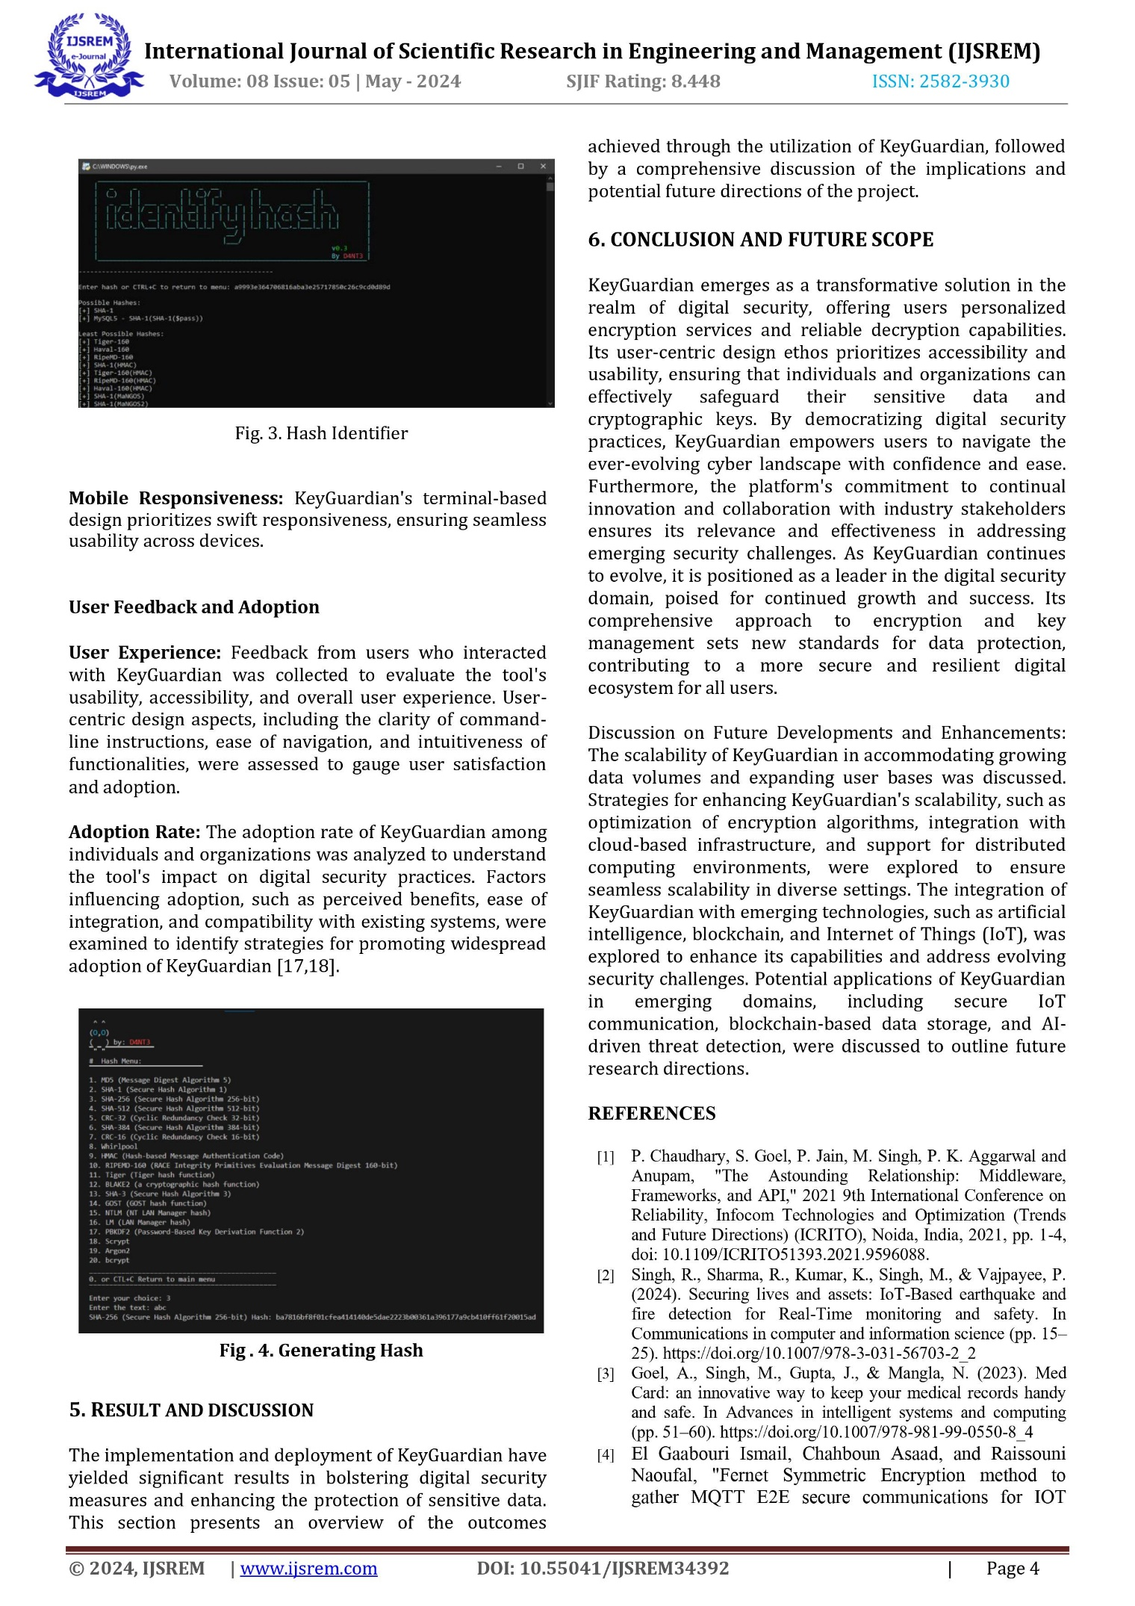



**ACCEPTANCE CERTIFICATE**



**PUBLICATION CERTIFICATE**

